# Department of Computing

**CS471: Machine Learning**

**Class: BESE-7AB**

**Lab 02: Linear Regression with One Variable**

**CLO2: Understand the wide variety of learning algorithms**

**Date: 01-02-2019**

**Time: 10:00 am– 1:00 pm & 2:00 pm-5:00 pm**

**Instructor: Dr. Pakeeza Akram**

**Lab 02: Linear Regression with One Variable Learning Outcome**

**Introduction**

* Linear regression with one variable — Finding the best-fitting straight line through points of a data set. [**(link)**](https://www.internalpointers.com/post/linear-regression-one-variable)
* The gradient descent function — How to find the minimum of a function using an iterative algorithm. [**(link)**](https://www.internalpointers.com/post/gradient-descent-function)
* The gradient descent in action — It's time to put together the gradient descent with the cost function, in order to churn out the final algorithm for linear **(**[**link**](https://www.internalpointers.com/post/gradient-descent-action)**)**

**Objectives**

* Implement gradient Descent for univariate linear regression.

**Tools/Software Requirement**

Python 3, Matplotlib, Numpy, Jupyter

**Task Description**

We have a file ext1data1.txt that contains the dataset for linear regression problem. The first column is the population of the city and the second column is the profit of having a store in that city. A negative value for profit indicates a loss.

Please see the Jupyter Notebook linearRegression_Lab02.ipynb and complete the tasks 1-3

The Jupyter Notebook is an open-source web application that allows you to create and share documents that contain live code, equations, visualizations and narrative text. You can find information about Jupyter notebook at [http://jupyter.org/index.html.](http://jupyter.org/index.html)

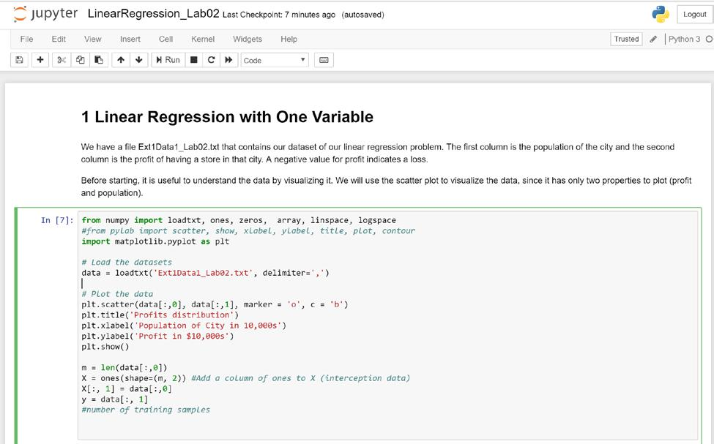

**Deliverables**

* Students are required to upload the lab task in solution in. ipynb format on LMS.
* The file name must contain your name and CMS ID in the following format.

<Lab02_your CMS ID_your name.ipynb>